impvolplot Packages Instruction:

Brief Introduction:

This package was built to calculate the implied Vol of future based on Black76 Model. The calculation employs bisection method for iteration. For the plotting part, since it has 5 variables (Option Price, Strike Price, Volatility, Future Price, Time to Expiry), I decided to use 3D plot to represent 3 variables in the graph. The other 2 variables to be put into the hover window of each point. Out of the 3 variable, one is Implied Vol and the other 2 can be modified. The color differentiates call option and put option. The Legend was clearly indicated on the top right. This plot is interactive; you can rotate or zoom the plot to have a better view.

Here is an example (x= strike, y=optionPrice, z=Volitality):

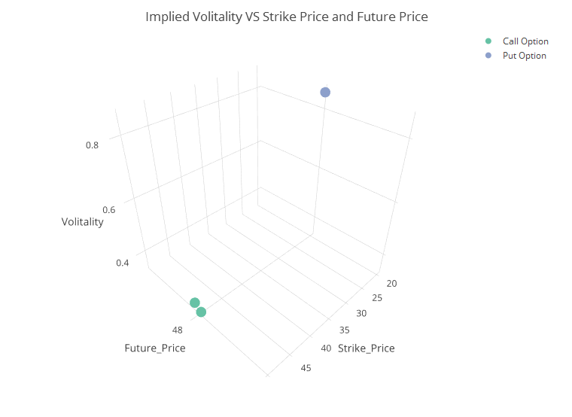

Usage:

* You can use the simple syntax to plot the Vol:

**plotimpliedVol(df)**

Using this, you use the default setting of risk free interest rate is 0.03 and plotting axis of strike price and option price.

* You can use more customized syntax to plot the Vol:

**plotimpliedVol(df, rate=0.07, x = strike, y = futurePrice)**

In this example, risk free interest rate was set to 0.07, and plotting axis was set to strike price and future price. Here is the plotting.



The Syntax is as follows:

**plotimpliedVol(df, rate=p , x = Option, y = Option)**

* **p can be any value that defines the risk free interest rate**
* **Option combination can be any one of the bellows (Cap words sensitive):**

**(x=strike, y=optionPrice)**

**(x=strike, y=futurePrice)**

**(x=strike, y=time_to_expiry)**

**(x=optionPrice, y=futurePrice)**

**(x=optionPrice, y=time_to_expiry)**

**(x=futurePrice, y=time_to_expity)**